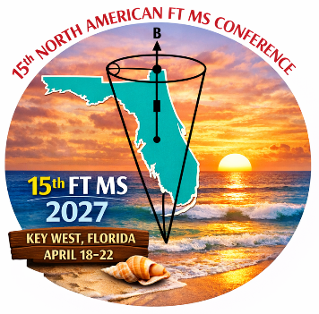
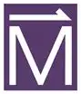

FT MS School
Key West, FL, April 18, 2027

8:30-8:40 am Welcoming remarks

8:40-9:20 am Mass Spectrometry - What do We Measure? From Molecular Composition to Structural Information (30 min) + questions (10 min)
Chris Hendrickson, retired

9:20 am-10:00 am ICR Fundamentals – How Do We Get To a Mass Spectrum? (30 min) + questions (10 min)
Jon Amster, retired

10:00-10:40 am Orbitrap Fundamentals – How Do We Get To a Mass Spectrum? (30 min) + questions (10 min)
John Syka, retired

10:40-11:00 am Coffee break

11:00-11:40 am What are the Parts of a Commercial ICR Instrument? (30 min) + questions (10 min)
Chris Wootton, Bruker Daltonics

11:40 am-12:20 pm What are the Parts of a Commercial Orbitrap Instrument? (30 min) + questions (10 min)
Mike Senko, Thermo Fisher Scientific

12:20-1:20 pm Lunch

1:20-2:00 pm FT MS Signal Processing and Simulation (30 min) + questions (10 min)
Yury Tsybin, Spectroswiss

2:00-2:40 pm Charge Detection Mass Spectrometry – How Does It Work? (30 min) + questions (10 min)
Michael Marty, The University of Texas at Austin

2:40-3:20 pm FT MS Imaging (30 min) + questions (10 min)
Madeline Colley, Vanderbilt University

3:20-3:40 Coffee Break

3:40-4:20 pm Data Processing: Complex Mixture Analysis (30 min) + questions (10 min)
Lydia Babcock-Adams, National High Magnetic Field Laboratory

4:20-5:00 pm Data Processing: Top-Down Proteomics (Direct Infusion and LC) (30 min) + questions (10 min)
Lissa Anderson, National High Magnetic Field Laboratory

